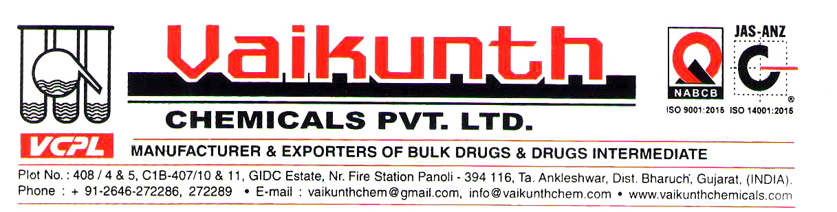

CERTIFICATE OF ANALYSIS
NAME OF PRODUCT: CETRIZINE DIHYDROCHLORIDE - EP10.0
BATCH/LOT NO. CTZ00323
DATE OF MFG: JANUARY - 2023
No. | Test | Specification | Observation
1 | Description | White or almost white powder | White powder
2 | Solubility | Freely soluble in water, practically insoluble in acetone and in Methylene chloride. | Complies
3 | Identification (First identification B, D and second identification A, C, D)
3 | By UV absorption | Specific absorbance at absorption maximum is 359 to 381 at 231nm | Complies
3 | By IR | The infrared absorption spectrum should be concordant with that of Cetirizine Dihydrochloride working standard | Complies
3 | TLC | Should match with working standard | Complies
3 | Chloride test | It gives reaction of chlorides | Complies
4 | Appearance of solution | Solution is clear and not more than intensely colored than reference solution BY7 | Complies
5 | pH (1.0g in 20ml water) | Between 1.2 and 1.8 | 1.40
6 | Loss on Drying | Not more than0.5% w/w | 0.20
7 | Sulphated Ash | Not more than 0.2% w/w | 0.06
8 | Assay by potentiometry | Between 99.0 and 101.0% w/w | 99.66
9 | Related Substances By HPLC
9 | Impurity A | Not more than 0.15% | Not detected
9 | Impurity B | Not more than 0.15% | 0.04
9 | Impurity C | Not more than 0.15% | Not detected
9 | Impurity D | Not more than 0.15% | Not detected
9 | Impurity E | Not more than 0.15% | 0.03
9 | Impurity F | Not more than 0.15% | 0.06
9 | Unspecified impurity | Not more than 0.1% | 0.03
9 | Total impurity | Not more than 0.3% | 0.15
Remarks: The material complies as per above specifications.
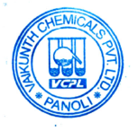
DATE OF EXP: DECEMBER – 2027 A.R.NO-:FP/22/051

